IMPORTANT INFORMATION!

Drop off Items
in the Oak Grove UMC Whitehurst Hall
Thursday, March 19 from 8:00 a.m. – 8:00 p.m

Presale for Volunteers
Friday, March 20, 2020
3:00 p.m. – 5:00 p.m.

**A 3% convenience fee will be added to all credit card purchases during sale No refunds or exchanges. All sales are final **

Oak Grove Children’s Consignment Sale
PUBLIC SALE : Friday, March 20, 2020
5:00 - 8:00 pm
HALF PRICE SALE : Saturday, March 21, 2020
8:00 a.m. – 1:00 p.m.

Pickup Unsold items
(items not marked to “Donate”)
4:00 - 5:00 p.m. on Saturday, March 21, 2020
In Oak Grove UMC Whitehurst Hall

**Please visit our website www.oakgrovechildrensconsignmentsale.com for information relating to tagging items.
Oak Grove Children’s Consignment Sale
Consignor Tagging Information

Tags: You MUST use Oak Grove Children’s Consignment Sale tagging system for tagging your items. Tags CAN NOT be reused from past sales, a new tag must be printed for each item, for each sale.

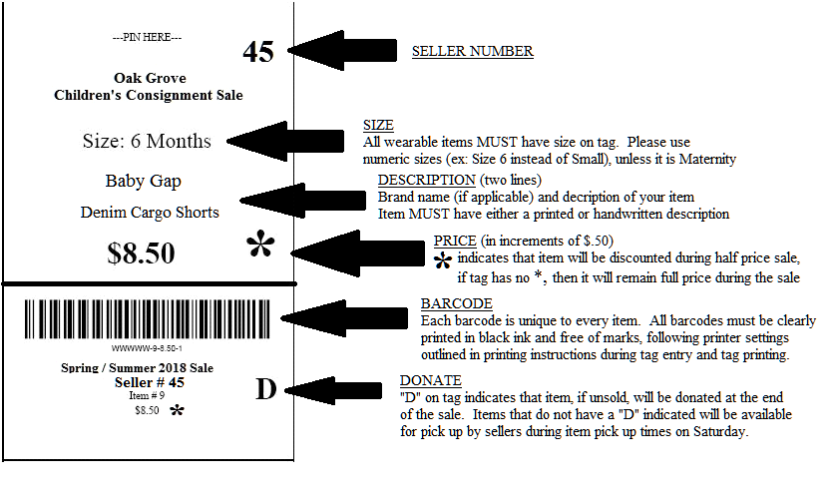
***The size and description are the only information that could potentially be handwritten. Any item not adhering to the tagging guidelines, may be subject to removal from the sale.***

- Please follow the exact instructions for tag printout to ensure that your items will scan correctly during the sale. The Oak Grove Tags must be printed from our online system. Printers must have adequate ink supply and only black ink may be used. Always make sure the barcode is printed clearly and can be easily removed with no tape covering any area below the black line on the tag, including the barcode.
- Please enter a size for all clothing, shoes, and wearable items. Please assign a numerical size to all clothing and shoes, with the exception of Maternity clothing (XS-XXL or numerical size). For example: If a boys shirt is labeled as a size small or S and it fits like a size 6, please label as a size 6. Please note slim, plus, or husky next to the numerical size, if applicable. Sizes may be left blank and handwritten on the tag after print out, if desired, but must have a size labeled on the tag if it is a wearable item.
- If you wish to donate your unsold item, please select the “Donate” check box when you are tagging your individual items. If you do not wish to donate an item please leave the “Donate” box unselected. Items selected for donation will have a ‘D’ printed on the lower portion of each item tag. If you have chosen not to donate your unsold items, you will be expected to pick it up between 4:00 pm and 5:00 pm on the last day of the sale, March 21, 2020. After 5pm, any items not picked up will be subject to donation.
- If you wish to sell your item at ½ price for the last day of the sale, please select the “Discount” check box when creating your tag. The items that are selected to sell at the discounted price in the ½ price sale will have an ‘ * ‘ next to the item price. The ‘ * ‘ will appear only when the item is selected for discount during item entry into the system.
- Please select Draft or Normal settings for print quality, as the Best quality print setting tends to smear. Tags MUST be printed on white cardstock paper, with a weight of 60-67lbs. (65lb cardstock is common and available at Walmart, or any office supply store). Black ink must be used and must have an adequate amount of ink in cartridge. Please consult the printer guidelines under the “Print Tags” section of your online seller account.
- Tags can be attached to toys, games, equipment, furniture, etc. with clear packing tape. Tape only the top ½ of the tag – so the bottom ½ with the barcode may be removed. Do not cover, alter, or tape any area below the black line on the tag in the barcode area.
- The Oak Grove Consignment Sale Tag must be attached to clothing with a safety pin or tagging barb on the left side of the clothing. To reinforce hanging tags, a small piece of clear scotch tape may be placed on the top of the tag where the pin or barb is attached.
- Hang all clothing on hangers with the hook facing LEFT. The hanger should look like a “question mark” when facing you.
- Use safety pins to attach pants, shorts, or skirts to the top of the hanger. Clip hangers may be used for pants.
- For multiple-piece outfits: pin pants, shorts, or skirts to back shoulders of the shirt.
- Socks, hair accessories, feeding supplies and other small items should be placed in Ziploc bags, securing the top with clear packing tape. Attach tag to outside of the bag with clear packing tape on the upper portion of the tag, above the line.
- Blankets can be folded neatly with tags attached to your right hand corner.
- Please place small parts for items, such as toys, into sealed plastic bags and securely attach to the larger item. It is also helpful to number (1of 2, 2of 2, etc.) & place your consignor number on all bags in multiple bag sets.
- Boutique Blue Ribbon! For items in the following brands, you should tie a blue ribbon at the top of the hanger or attach to the item to indicate a boutique brand! This will help buyers identify boutique brands more easily and earn you more money for your high quality items! Brands include:

o Mini Boden
o Baby Boden
o Tea Collection
o Lilly Pulitzer
o Ugg
o Mini Melissa
o Janie and Jack
o See Kai Run
o Matilda Jane
o Hanna Anderson
o Hunter
o Shrimp and Grits
o Eleanor Rose
o Baily Boys
o Chocolate Soup
o Vineyard Vines
o Vive la Fete
o Anavini
o Crescent Moon
o Petit Ami

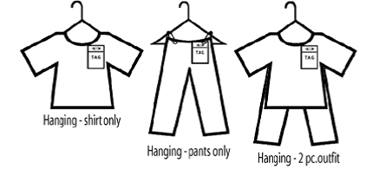

Prices: You are responsible for pricing your items. All prices must be in increments of
50 cents (.50, $1.50 etc.). The minimum price for any item is 50 cents. See our “Suggested
Price List” at www.oakgrovechildrensconsignmentsale.com for ideas.

Items accepted: All items accepted must pertain to children.
All items will be inspected before being placed into the sale. We reserve the right to remove items from the sale that do not meet our criteria based on the guidelines listed. Please assist us by adhering to our policies.

Children’s clothing sizes 0-20 (no juniors)
- Including shoes, dancewear and swimsuits.
- All clothing must be in good condition and in current style.
- For the March sale, we will only be accepting Spring and Summer clothing.
- Underwear, socks or tights must be like new
- We will not accept clothing in faded condition with stains, holes, unpleasant odors or pet hair.
- Check all clothing for necessary repairs – i.e. sew on missing buttons, soak out stains.
- Button all buttons, snap all snaps and zip all zippers
- Ironing clothing increases your sales dramatically. Clothes that are ironed sell quicker and for a higher price. At minimum, please consider ironing dresses and dress clothes.

Toys
- Include books (parenting, pregnancy & children’s), DVD’s, outdoor toys, bikes, riding toys, board games, puzzles, stuffed activity dolls (like talking Elmo) and electronic games.
- All games and puzzles should be complete.
- Please clean all washable toys, plastic toys, bikes and outdoor equipment.
- We will not accept dirty or broken toys
- Please package small pieces of games, puzzles, toys or any items with multiple components in a clear zipper-type bag and attach it to the larger unit with clear packaging tape. On the sale tag, note the number of bags that are included with the item in the description. Please tape the bag closed to minimize the possibility of losing pieces.
- ** Put new batteries in toys that require batteries, to ensure it is in proper working order. Toys without batteries will be removed from the sale. **

Baby items
- We will accept high chairs, swings, pack and plays, toy boxes, child-sized tables & chairs, bassinets, changing tables, beds, bathtubs, feeding items, desks, dressers and rocking chairs.
- Cribs must meet current safety standards. MUST HAVE a manufactured date visible on them, which is 1990 or later; all hardware must be included) NO DROP-SIDE CRIBS.
- Crib linens must be packaged together.
- Strollers must be clean with all cloth parts washed.
- Car Seats must be less than 6 years old and a “Car Seat Form” must be completed. The “Car Seat Form” will be available at Drop-off.
- Please be sure no items have been part of a manufacturer recall

Maternity Clothing
- Spring & Summer styles only
- Items over 5 years old typically do not sell

Volunteering:
- Anyone can volunteer! If you wish to volunteer for at least one 3 hour shift you will receive:
- 70% of the proceeds of your items (rather than 60%)
- You and 1 guest may shop the volunteer sale (Friday March 20, 2020)
- If you wish to volunteer for TWO SHIFTS or a shift that counts as two you will receive:
- 70% of the proceeds of your items (rather than 60%)
- Shop the presale FIVE MINUTES earlier! (one person only for the early pass, one additional guest may enter the single shift presale)
Drop off & Pick up: Please drop off your items at the Oak Grove UMC Whitehurst Hall:

Thursday, March 19 from 8:00 a.m. – 8:00 p.m

Clothing and shoes need to be presorted by size and gender. Like items should be grouped together. Please anticipate at least 1 hour or longer to ensure your items are sorted properly. You are responsible for placing your items in the appropriate location on the sales floor. Volunteers will be going through items to ensure that your items meet our standards of quaility. Please reference accepted items paragraph to ensure consignment item standards are met.

Pick up on Saturday, March 21st from 4:00-5:00pm. Items will be sorted for you to go in and pick up. Please bring any containers of items needed to transport to your vehicle. (Items may not be bagged as they have been previously.)

½ Price Sale: If you have indicated on the tag “Discount” for ½ price sale, the item will be sold at ½ price on the last day of the sale on March 21st.
All items sold As-is. No refunds / No exchanges. ALL SALES ARE FINAL

Proceeds check: As a consignor you will receive 60% of the proceeds of your sale. The remaining 40% will be used to fund our Oak Grove Preschool & Kindergarten and children’s ministry. If you volunteer for one 3 hour shift, you will receive 70% of the proceeds and OGUMC will receive 30%. Please visit our website to see all that Oak Grove United Methodist Church does for our community and find out more information on our preschool & kindergarten programs. Your proceeds check will be mailed to the address designated on the Consignor Agreement Contract Form.

